# **PF Lab Task #03:**

**Question 01:**

ANSWER:

In the program the value of test Integer is greater than the value that can be stored in the int data type therefore the value that is being displayed on the screen is not the value that is initialized to the test Integer. Basically, the int data type can only store numbers from -32768 to 32767.

**Question 02:**

ANSWER:

**Code:**

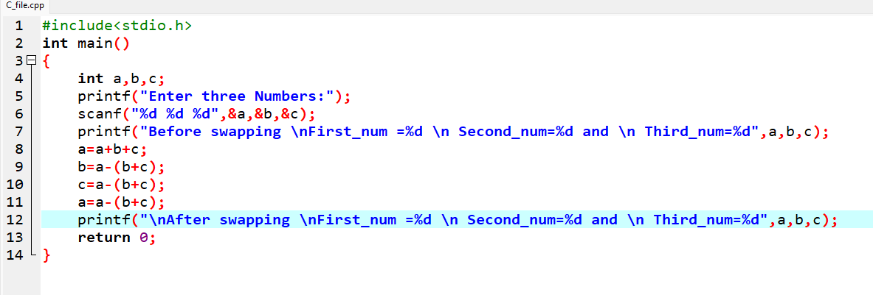

**Output:**

**Question 03:**

ANSWER:

**Code:**

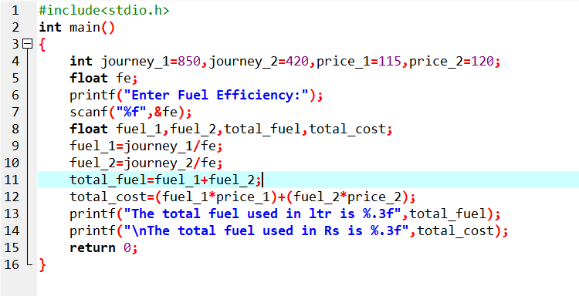

**Output:**

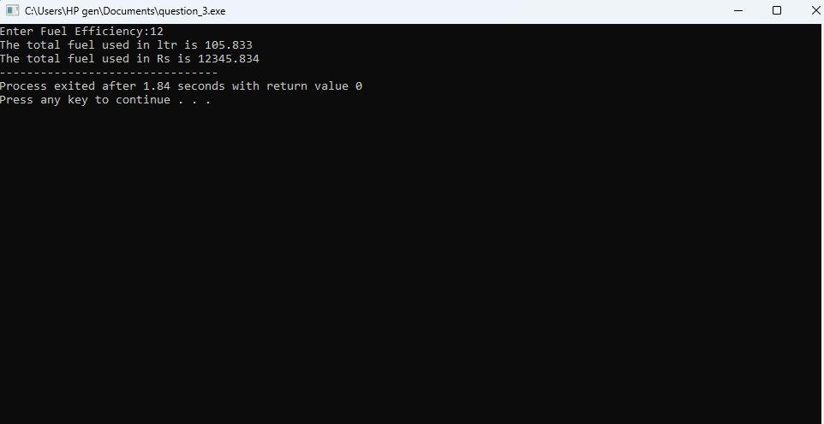

**Question 04:**

ANSWER:

**Code:**

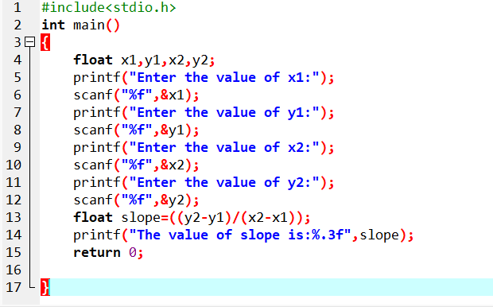

**Output:**

**Question 05:**

ANSWER:

**Code:**

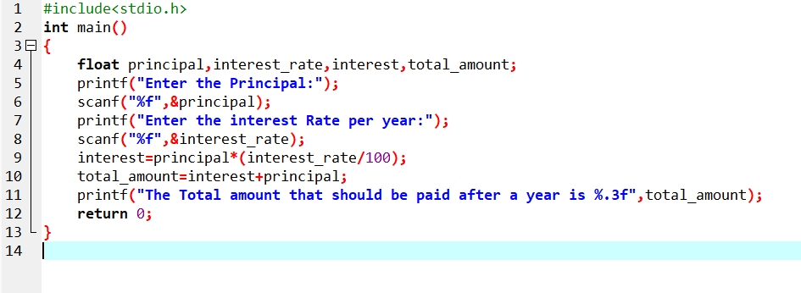

**Output:**

